**FINAL PROJECT IN COMPUTER SCIENCE**

**TECHNICAL REPORT**

**CRIME MAP APPLICATOIN**

**SUPERVISOR:**

**STUDENT: TIYA – CHANEL ANDERSON**

**LINK TO GITHUB:**

**Abstract**

**This report offers an insight into the value of a crime map application tailored specifically for young adults, backed by its technical background. By examining existing applications in the market, we aim to refine and innovate upon them to develop our unique app. Leveraging Google Maps APIs and crime report APIs, our goal is to provide users with comprehensive and up-to-date information to fulfil the app's purpose effectively. Through thorough research, modelling, design, and evaluation processes, we have identified a clear need for our Crime Map application. The inspiration for this idea arose from personal experiences of growing up in London, where daily encounters with crime underscored the necessity for such a tool. We envision our app serving as a valuable resource for individuals navigating London, offering insights that enhance safety and awareness in their travels.**

**In addition to the endeavours, I will undertake the creation of a comprehensive technical report detailing the development process of our product. This report will serve as a guiding document, taking stakeholders through each stage of the technical journey, from inception to implementation. Through detailed analysis and explanation, it will provide insights into the technical decisions made, the challenges encountered, and the solutions devised throughout the development lifecycle. By transparently documenting our technical approach, methodologies, and outcomes, we aim to ensure clarity and understanding among stakeholders while fostering confidence in the reliability and robustness of our Crime Map application.**

**Target audience**

**1. Target audience**

**My website targets a dynamic demographic of young adults, aged between their late teens and early thirties, who are deeply concerned about safety and community well-being. With a proactive approach to addressing societal issues, they are tech-savvy, socially conscious, and eager to make a positive impact. This audience seeks innovative solutions to pressing challenges, such as crime prevention and public safety. Your crime map, designed to detect and visualize crime data to aid in preventing deaths and other incidents, resonates strongly with their desire for accessible tools that empower individuals to safeguard themselves and their communities. They value transparency, efficiency, and collaboration, making them receptive to platforms that harness technology for the greater good. Engaging this audience requires clear communication of the map's features, its potential impact, and actionable steps users can take to contribute to a safer environment.**

**1.2 target audience platform choice**

**Opting to create a website instead of a mobile application for my crime map project was a deliberate decision rooted in accessibility and user convenience. Recognizing that many individuals within my target audience, particularly young adults, may have limited storage space on their devices and may not be inclined to download additional apps, I aimed to provide a solution that minimized data consumption and eliminated the need for app installations. By offering a website, users can access the crime map directly through their mobile browsers without the hassle of downloading and installing a separate application, catering to the preferences of those who prioritize simplicity and efficiency. Moreover, a website ensures accessibility across a broader spectrum of users, including those of all ages who may not have access to app stores or who may be less familiar with app installation processes. This approach aligns with my goal of making the crime map widely accessible and user-friendly, empowering individuals from diverse backgrounds to engage with the platform and contribute to community safety efforts.**

**Goals and objectives**

**2. With a focus on enhancing community safety and awareness, my website aims to achieve several key goals and objectives. Firstly, it seeks to provide users, particularly young adults in London, with easily accessible and comprehensible information about crime incidents within the city. By presenting detailed crime data in a user-friendly format, the website empowers individuals to make informed decisions about their safety and take proactive measures to protect themselves and their communities. Secondly, the website endeavours to keep users up to date with the latest news updates, ensuring they stay informed about relevant events and developments impacting London. By offering a holistic view of both crime trends and current affairs, the platform fosters a sense of awareness and engagement among its users. Additionally, by opting for a website over a mobile application, the goal is to maximize accessibility for users of all ages and technological backgrounds, catering to those with limited storage space and those without access to app stores. Ultimately, the overarching objective is to create a valuable resource that empowers London residents and visitors to navigate their city safely and stay connected with the latest information.**

**Market Research**

**The main purpose of the project is to make a website using google and police database API’s to create a crime map that will help people deter and detect crime within London. With that being said a few aspects had to be considered before commencing with the websites design process. I created mind maps and wireframes to begin with my ideas.**

[**https://centreforlondon.org/reader/the-london-intelligence-april-2022/personal-safety/**](https://centreforlondon.org/reader/the-london-intelligence-april-2022/personal-safety/)

**(blue = unsafe yellow = safe)**

[**https://www.ons.gov.uk/peoplepopulationandcommunity/crimeandjustice/bulletins/perceptionsofpersonalsafetyandexperiencesofharassmentgreatbritain/16februaryto13march2022/previous/v1**](https://www.ons.gov.uk/peoplepopulationandcommunity/crimeandjustice/bulletins/perceptionsofpersonalsafetyandexperiencesofharassmentgreatbritain/16februaryto13march2022/previous/v1)

**After conducting some thorough market research to see whether my product was needed, I found a few surveys that were conducted externally and that showed some insightful information that would lead me to understand that my product is needed within the market.**

**Upon my findings are released that there was a lot of mixed opinions regarding safety within London. However, I also realised that London is a very big population, and many has not partaken in these surveys. so, it would be unfair to test my products needs based on these surveys. so, I still went ahead with my idea despite my findings.**

**USE CASES**

**USE CASE 1**

1. **The user will open the web application.**
2. **The user is greeted with a user friendly interface that prompts him to enter his location or search for a specific area**
3. **User enters their address into the search bar and clicks on the enter button.**
4. **The website displays a map of neighbourhood with markers indicating recent crime incidents**

**EXTENSION OF CASE 1**

1. **If the user encounters any issues or difficulties using the website. He can access contact us section.**

**USE CASE 2**

1. **USER VISITS THE WEBSITE USING HER WEB BROWSER**
2. **ON THE HOMEPAGE, THE USER SEES A PROMINENT “SIGN UP” BUTTON AND CLICKS ON IT TO BEGIN THE REGISTRATION PROCESS**
3. **THE WEBSITE PRESENTS THE USER WITH A REGISTRATION FORM, PROMPTING THEM TO ENTER REQUIRED INFORMATION SUCH AS THEIR FULL NAME, EMAIL ADDRESS AND PASSWORD**
4. **THE USER FILLS OUT THE REGISTARTION**
5. **AFTER COMPLETING THE FORM, SHE CLICKS ON THE SIGN UP BUTTON.**
6. **THE WEBSITE THEN VERIFIES THEM AND ASK IF THEY WANT TO SAVE THEIR PASSWORD WITH GOOGLE.**

**USE CASE 3**

1. **USER NAVIGATED THE WEBSITE USING HIS WEB BROWSER**
2. **ON THE HOMEPAGE, HE FINDS A LINK TO THE “LATEST NEWS PAGE” AND CLICKS ON IT TO ACCESS THE ARTICLES**
3. **THE WEBSITES LOADS THE LATEST NEWS PAGE, DISPLAYING A LIST OF NEW ARTICLES RELATED TO CRIME, SAFETY AND SECURITY ISSUES IN HIS CITY**

**low-fidelity wireframes**

**I used this wireframe shown in the figure above as a guideline of how I intended to build my website. I knew that one of my main focuses was implementing the google map API**

**Technical Architecture**

**I decided to use React to code my front – end website because it simplifies the process of creating user interfaces for my web application alongside HTML and CSS as I have a lot of experience doing so and I feel comfortable with these languages to style my pages. With React, I can build different parts of my website, like buttons or forms, as separate pieces that I can reuse wherever I need them. This makes my code easier to manage and saves me time. Plus, reacts way of writing code, called JSX, feels more like writing regular HTML, which makes it easier for me to understand and work with. It also helps my website run smoothly by making sure only the necessary parts get updated when things change, which keeps everything running quickly and smoothly for my users. Overall, react gives me the tools I need to build a great website without getting bogged down in technical details.**

**once I grasped the fundamentals of JavaScript. The two share many similarities in syntax and structure, which made transitioning to React a natural progression. Like JavaScript, React relies on familiar concepts such as functions, variables, and control flow statements, allowing me to leverage my existing knowledge seamlessly. However, React introduces its own unique concepts, such as components and JSX, which initially seemed daunting but quickly became intuitive once I understood their purpose. Components in React are akin to reusable building blocks, much like functions in JavaScript, enabling me to break down complex UIs into manageable pieces. JSX, on the other hand, resembles HTML syntax but is JavaScript, enabling me to write UI code in a familiar and expressive manner. By building on the foundation of JavaScript, React provided me with a powerful toolkit for creating dynamic and interactive user interfaces with ease.**

**IMPLEMENTING API’s**

**API stands for Application Programming Interface, and is a set of protocols that enables software to communicate with each other [11]. APIs are essentially a series of requests and responses between a client and server, where APIs act as a step between the two.**

**Types of APIs**

**There are four types of API that we see being used - Open/Public APIs, Internal/Private APIs, Partner APIs, and Composite APIs.**

**- Open APIs: available to everyone and intended to be used by external people such as developers in other companies.**

**- Internal APIs: used within a single company, allowing developers to share**

**resources, not accessible for external developers.**

**- Partner APIs: restricted access, like open APIs but not everyone can use these APIs - intended for a specific purpose**

**- Composite APIs: can perform multiple tasks or access multiple data sources,**

**work well to improve software performance and server load.**

**[12]**

**API Architecture**

**REST (representational state transfer) APIs are maybe the most popular API**

**architecture. REST APIs follow a client-server approach [13]. REST APIs work well with data.**

**Therefore, the API I decided to implement into my project is an express REST API. Meaning that the API Is built using the express framework allowing principles of REST**

**Here in the figure above you can see me making an HTTP request to an external API (police data) to fetch data for my crime map. This allows me to gather all information on crime that took place within the area of Leicester and pinpoint on my Google map. To also get the google map I had to request a separate HTTP to have the map functioning on my page.**

**If the frontend is responsible for rendering the user interface and interacting with an external API for data, the setup would be different from a full-stack application. In this scenario, the frontend would be a standalone React application that makes HTTP requests to an external API to fetch data.**

**In this example, the fetchData function makes an HTTP GET request to the external API endpoint (https://data.police.uk/api/crimes-street/all-crime) to fetch a list of crime data. Once the data is retrieved, it's stored in the component's state and rendered in the UI.**

**The external API (https://data.police.uk/api/crimes-street/all-crime) is responsible for providing the data needed by the frontend. Meaning this could be built using any server-side technology (Node.js, Python, etc.) and is hosted separately from the frontend application.**

**In summary, the React frontend is acting as a client that consumes data from an external API. The frontend and backend are decoupled, allowing me to achieve greater flexibility and scalability in my architecture.**

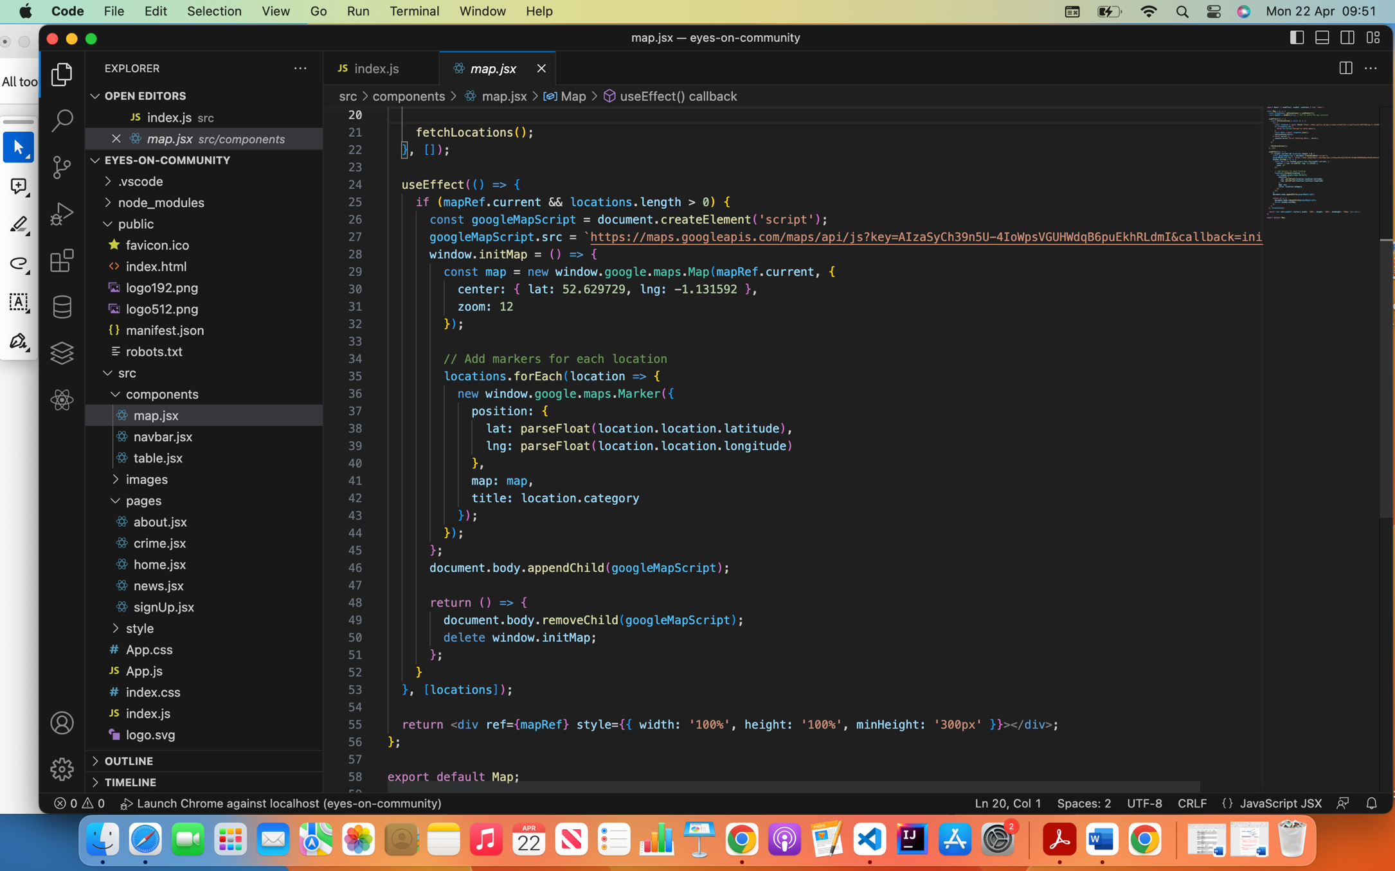

**Continuing from the other API shown in the figure above. This is the API to request the google map. If you can see on approximately line 9. This is the co-ordinates for the location I wanted to base the crimes in. and below that is the adding of the markers for each location I am presented from taken from the Police API data.**

**Ethical Considerations**

**In developing my website, I've been conscientious about ensuring its ethical integrity, particularly when integrating an external API for accessing data. Recognizing the significance of user privacy, I've implemented stringent measures to safeguard personal data, adhering to established data protection regulations such as GDPR. Transparency and user consent have been paramount, with clear communication provided regarding data usage and collection practices. Moreover, I've diligently assessed the ethical implications of utilizing the external API, meticulously scrutinizing its terms of service and privacy policies to ensure compliance and fair use. To mitigate potential biases and discrimination, I've actively sought diverse and representative datasets, striving for inclusivity and fairness in data representation. By prioritizing ethical considerations throughout the development process, I've endeavoured to create a website that not only delivers valuable insights but also upholds the highest ethical standards, earning the confidence and trust of users.**

**Heuristic Evaluation**

**In the above figure I have conducted a Heuristic evaluation to access the usability of my website. Conducting heuristic evaluations on websites is crucial for identifying usability issues early in the design and development process, improving the overall user experience, guiding design decisions, validating design choices, and supporting iterative improvement. By systematically assessing the website against established usability principles or heuristics, we can uncover usability problems, prioritize improvements, and create a more user-friendly and effective website that meets the needs and expectations of its users.**

**Project Management**

**EVAULATON**